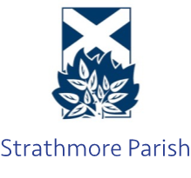  Strathmore Parish Church of Scotland  Registered Charity Number: SC013352  https://www.strathmoreparish.org/ |  | Interim Moderator: Rev. John Duncan  jduncan@churchofscotland.org  Ordained Local Minister: Rev. Tim Podger  tpodger@churchofscotland.org.uk  Session Clerk: Mike Riddell-Webster  session.clerk@strathmoreparish.org
Fees for use of one of our churches (2026/27)
(Glamis, Kettins, Meigle, Newtyle)

Weddings | Use of the church building  Services of an organist (optional) |  | £410  £120
Funerals | (normally arranged by the funeral director)  Use of the church building  Services of an organist (optional) |  | £210  £120

Please note, for weddings, we only allow the throwing of confetti outside our church buildings. Confetti should be completely biodegradable e.g. flower petals

