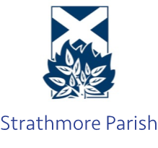  Strathmore Parish Church of Scotland  Registered Charity Number: SC013352  https://www.strathmoreparish.org/ |  | Interim Moderator: Rev. John Duncan  jduncan@churchofscotland.org  Ordained Local Minister: Rev. Tim Podger  tpodger@churchofscotland.org.uk  Session Clerk: Mike Riddell-Webster  session.clerk@strathmoreparish.org
Fees for use of one of our churches (2026/27)
(Glamis, Kettins, Meigle, Newtyle)

Weddings | Use of the church building  Services of an organist (optional)  Services of the church officer |  | £350  £120  £60
Funerals | Use of the church building  Services of an organist (optional)  Services of the church officer |  | £150  £120  £60

Please note, for weddings, we only allow the throwing of confetti that cannot be considered litter and is completely biodegradable e.g. flower petals

